  
**FPT APTECH PATIENTINFOSYSTEM**

Dương Văn Tùng A05020

Nguyễn Văn HinhA05084

Đỗ Duy Tùng A05062

Nguyễn Ngọc Thiên A05035

Installation Guide

DOCUMENTATION

1. ***Software Requirement.***

* Java SE 7
* SQL 2005

1. ***Configuration***
2. **Connect SQL**
   * Run SQL Server Management St

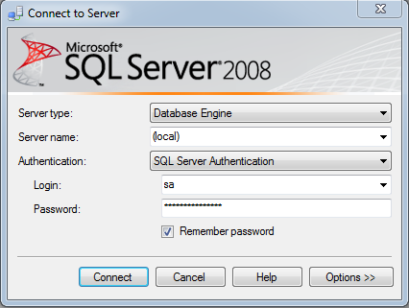

* + Right click to Database then choose Attach…

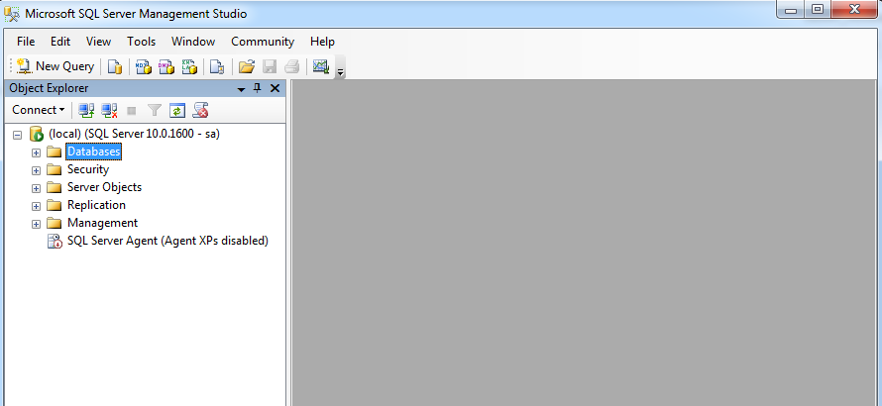

* Click to Add, Locate Database File windows open, then choose destination folder which contains **PI.mdf** file, then click OK.

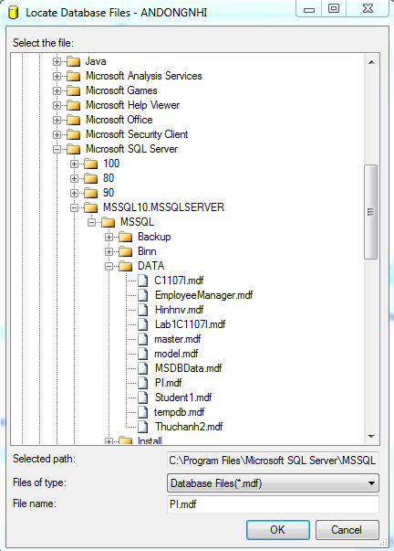

* Click OK to finish adding database, then close SQL Server Management Studio

Run F5

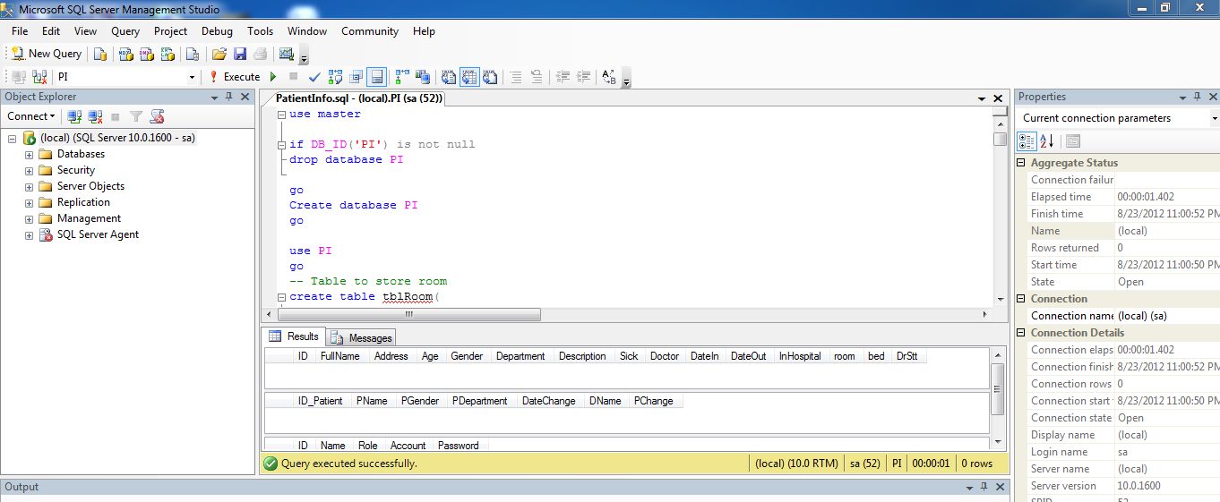

1. ***Run program***

* Run NetBeans.

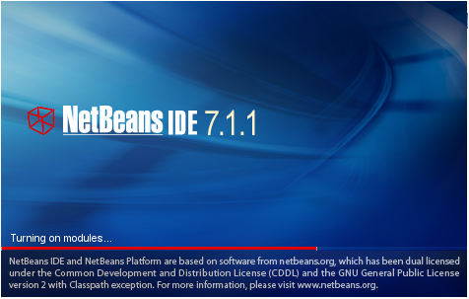

* Click to menu File → Open Project → choose destination folder that contain Marvell folder.

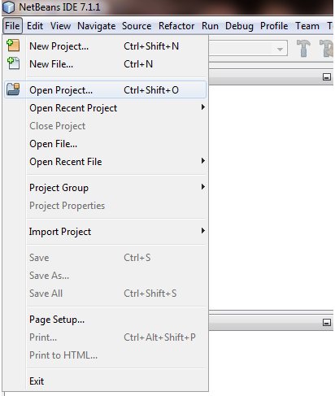

* choose that folder and click Open Project button

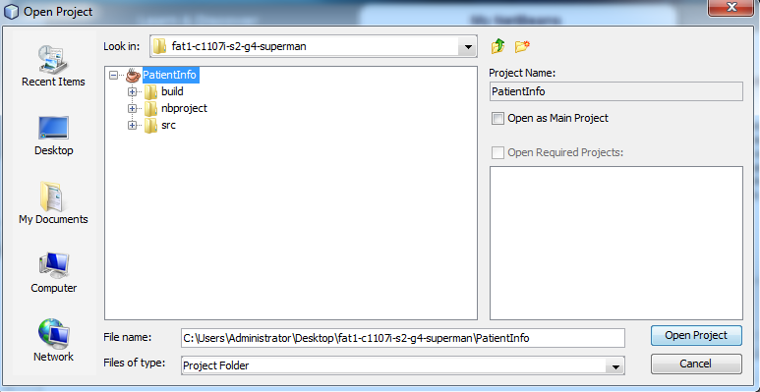

Right click to Marvell  project and click Run

